DATA ARCHITECTURE
What
The Automated Network Request Management solution uses a structured ServiceNow data model to store and manage information required throughout the network-request lifecycle.
A dedicated custom table is created to maintain network-related request information. The table contains fields for request identification, assignment, requester details, payment information, connection type, address, and approval status.
The data model provides a structured foundation for forms, approvals, automation, operational tracking, and reporting.
Why
A well-defined data architecture is required to ensure that information entered by users is:
- Stored consistently.
- Easy to retrieve and track.
- Available to approval and fulfilment processes.
- Suitable for automation.
- Accurate enough for reporting and auditing.
- Controlled through ServiceNow access and platform capabilities.
Using a dedicated table also provides a clear separation between the application's network-specific information and unrelated platform data.
How
The data architecture will be implemented in two activities:
- Creation of the custom table
- Creation and configuration of fields

Activity 1 – Creation of Table
What
Create a dedicated custom ServiceNow table to store the required network database/request information.
Why
The table acts as the primary data structure for storing records generated by the network request process. Creating a dedicated table makes the data easier to manage, automate, and report on.
How
- Navigate to:
All → System Definition → Tables
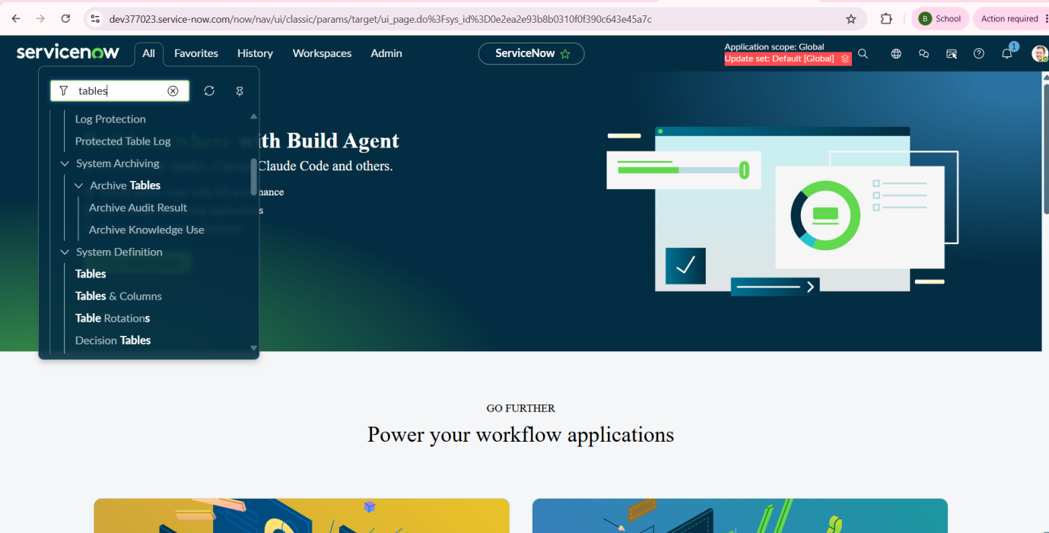
- Click New.
- Enter the table information provided in the project requirements:
Label: Database Tables
Name: u_database_table
- Review the configuration.
- Click Submit.
- Search for Database Tables in the table list.
- Open the newly created table to verify that it exists.
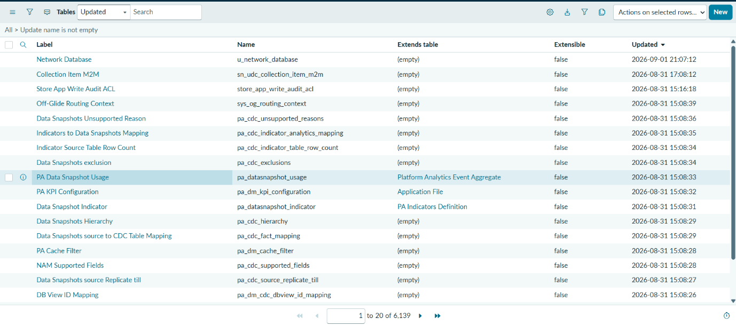
Capture the Table configuration form showing:
- Label: Database Tables
- Name: u_database_table
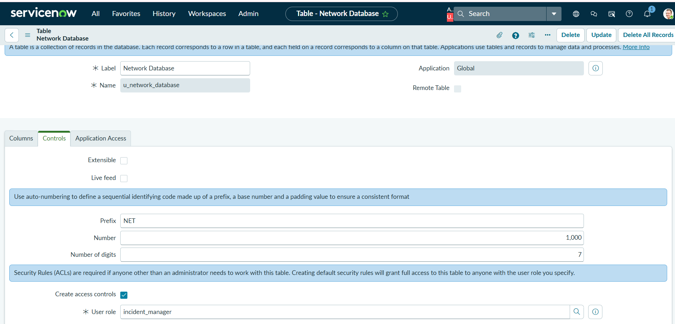
Outcome
The custom Database Tables (u_database_table) table is successfully created and is ready for field configuration.
Activity 2 – Creation of Fields
What
Configure the fields required to capture and manage network database/request information.
Why
The fields define the information that users and fulfilment teams need to provide or maintain. Appropriate field types improve data consistency, while reference fields allow records to be associated with existing ServiceNow users.
How
- Navigate to:
All → System Definition → Tables
- Search for Database Tables.
- Open the Database Tables table.
- Use the table's column/field configuration to create the required fields.
- Configure the fields according to the following specification.
Required Fields

Field | Type | Reference
Database Number | String / Auto Number | —
Assignment to | Reference | User
Mobile Number | String | —
Total Amount | String | —
Mode of Payment | String | —
Type of Connection | String | —
Customer Address | String | —
Approval Status | String | —
Requested For | String | —

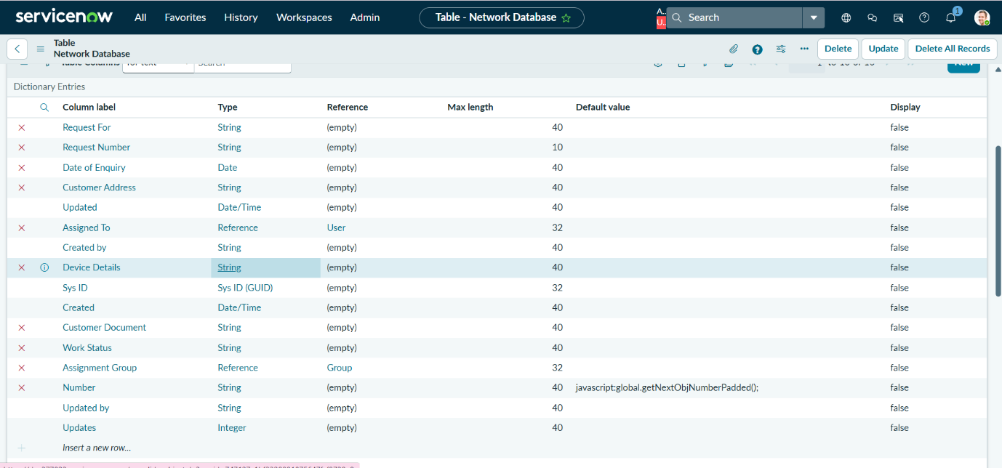
Database Number – Auto Number Configuration
The Database Number field should be configured as an automatically generated identifier where required by the lab instructions.
Configure:
- Auto Number: Enabled
- Prefix: Use the prefix specified by your project/lab
- Number format: Use the required number format
This ensures that each record can be uniquely identified.
Assignment to – Reference Field
The Assignment to field should be configured as a Reference field pointing to the User table.
This allows the record to be associated with an existing ServiceNow user instead of storing the user's name as unrestricted text.
Form Design
After creating the fields:
- Open the table.
- Select Form Design.
- Arrange the fields in the required order.
- Place related fields together logically.
- Save the form.
- Open a sample Network Database record to verify the fields.
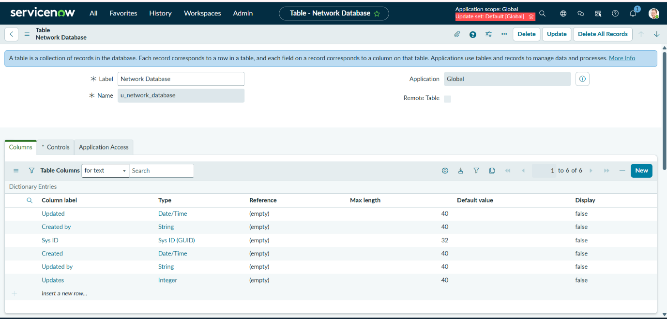
Outcome
The data architecture establishes a structured foundation for the Automated Network Request Management solution.
After completion:
- A dedicated custom table exists.
- Required network/request fields are available.
- Records can be uniquely identified.
- Users can be referenced through ServiceNow user records.
- Request information is stored in a consistent structure.
- The data can subsequently be consumed by approval flows, fulfilment automation, notifications, dashboards, and reporting.
Replicability Note
Note: The exact field types and naming should follow the capstone/lab specification. In particular, fields such as Total Amount, Mobile Number, Approval Status, and Type of Connection are currently specified as String fields in the supplied requirements. If later phases use these values for calculations, filtering, or conditional automation, we should review whether a more specialized ServiceNow field type is appropriate.

